|  |
| --- |
|  |
|  |

|  |  |  |  |  |  |
| --- | --- | --- | --- | --- | --- |
| REVISION HISTORY | | | | | |
| Ver. | Description of Change | Author | Date | Approved | |
| Name | Effective Date |
| 1.0 | Initial status | Olga_Hilko | 04-DEC-2017 |  |  |

Contents

1. DDL required objects 3

2. Grant on fact objects 3

3. Fact generate and load to 3NF 4

3.1. Generate 4

3.2. CL_to_3NF 5

4. Fact Data 5

# DDL required objects

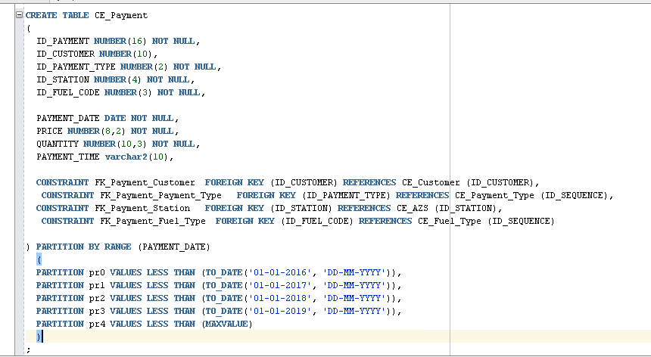

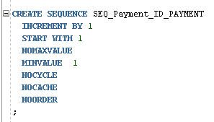

# Grant on fact objects

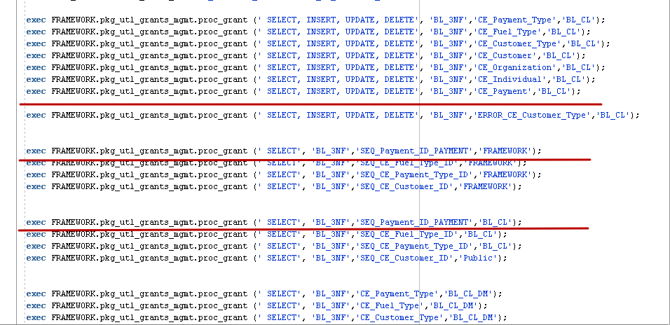

# Fact generate and load to 3NF

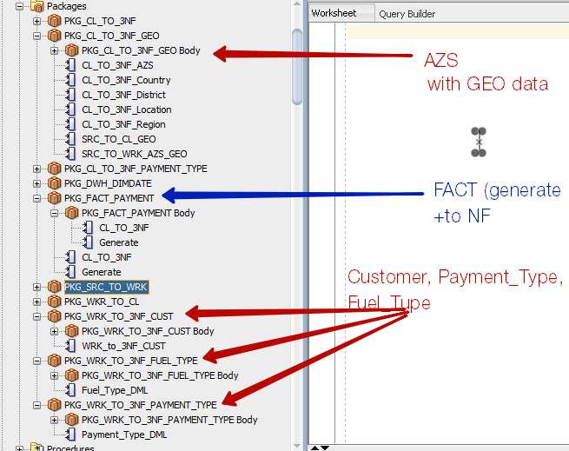

## Generate

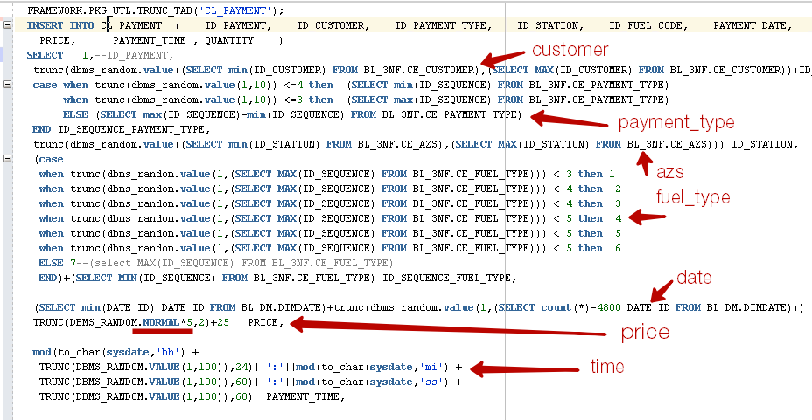

## CL_to_3NF

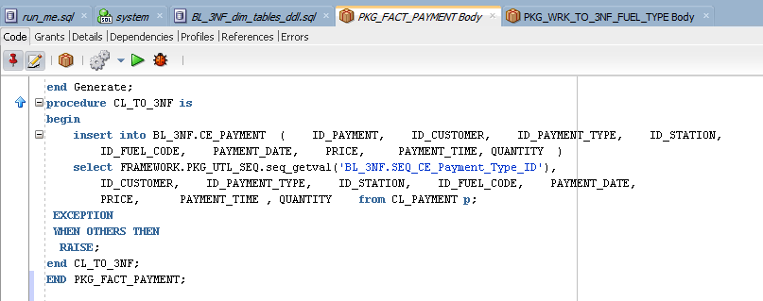

# Fact Data

